Homework 1

1.

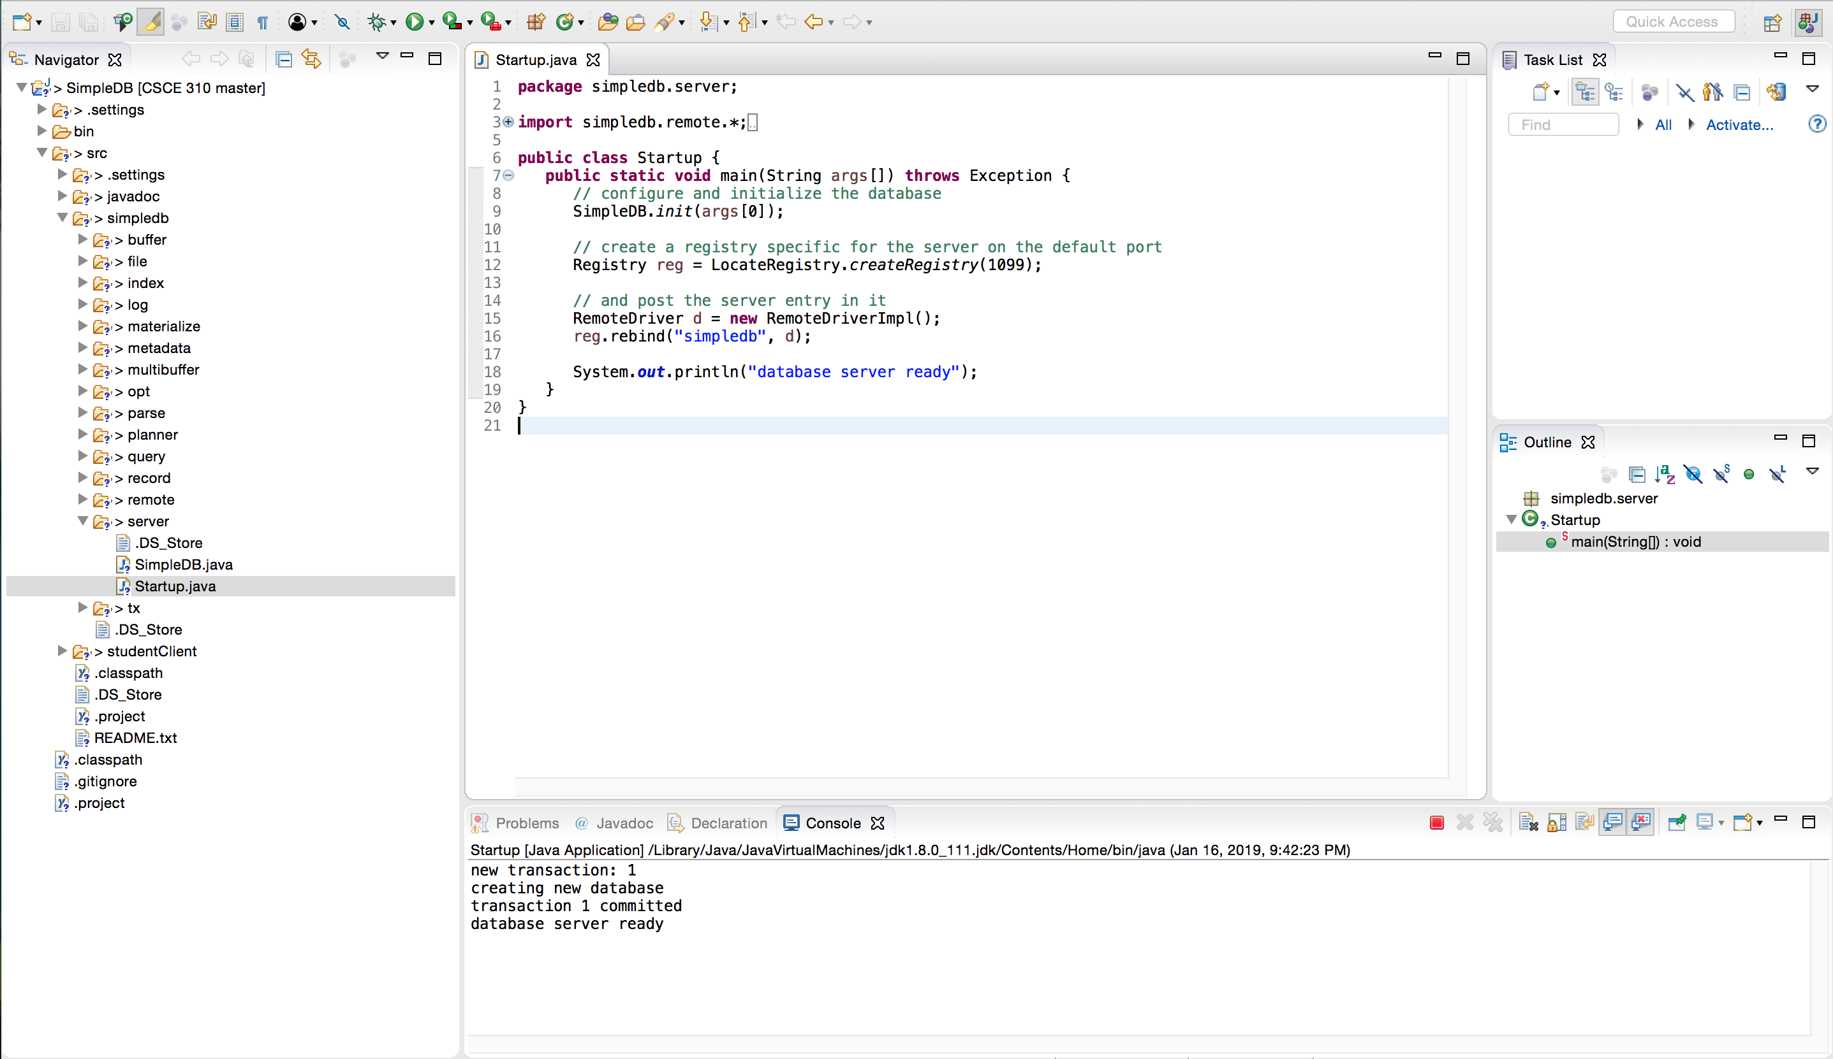

The Red rectangle is a button to send a kill signal to the process running the server.

2.

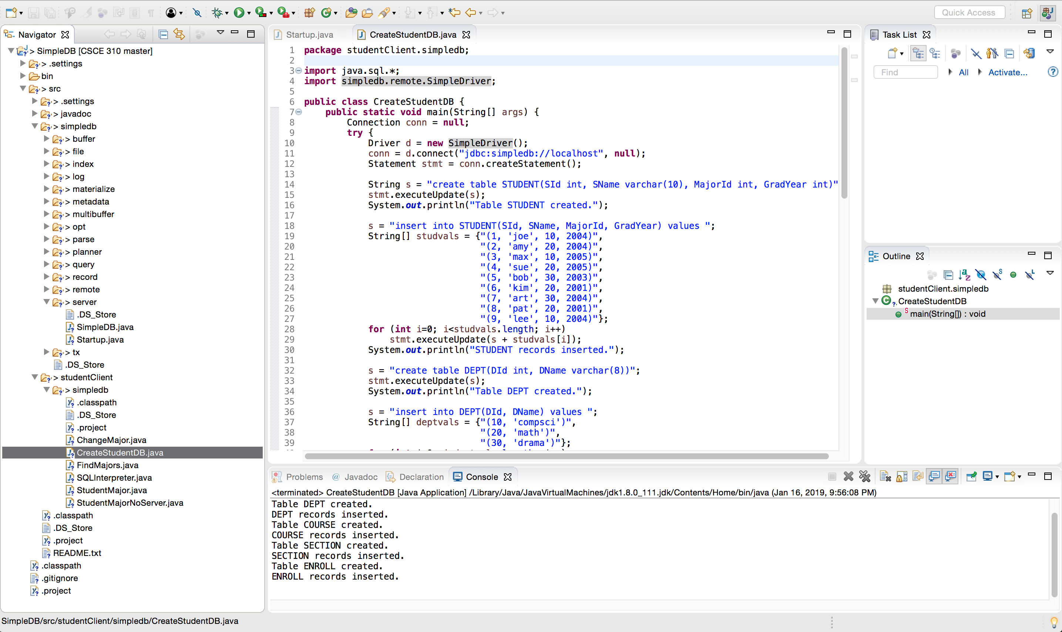

The code creates 5 tables and inserts a record into each table.

3.

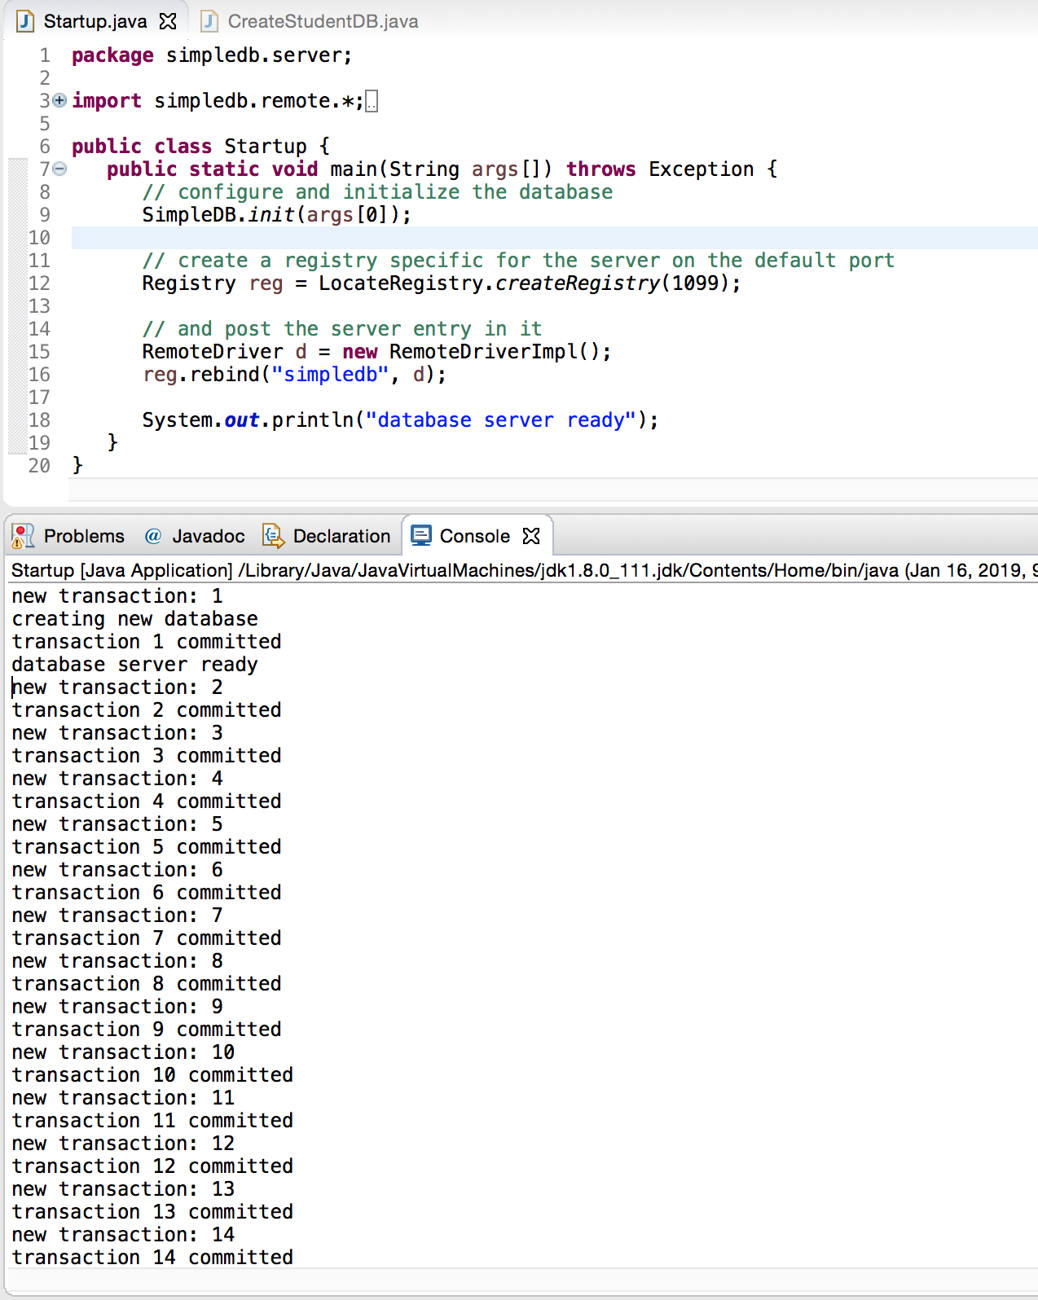

The red rectangle is still present because the server is still running

4. Any file with the file extension of “.tbl” is a file that is a table. CreateStudentDB is the file that actually create the database tables.

Derby ij Console Output

**○** → java org.apache.derby.tools.ij

ij version 10.13

ij> connect 'jdbc:derby:manfDB;create=true';

ij> create table product (maker char(1), model char(4), type varchar(8));

0 rows inserted/updated/deleted

ij> create table pc (model char(4), speed float, ram int, hd int, price decima(4,0));

0 rows inserted/updated/deleted

ij> create table laptop (model char(4), speed real, ram int, hd int, screen decimal(3,1), price decimal(4,0));

0 rows inserted/updated/deleted

ij> create table printer (model char(4), color varchar(5), type varchar(8), price decimal(4,0));

0 rows inserted/updated/deleted

ij> INSERT INTO printer VALUES ('3001','true','ink-jet',99);

1 row inserted/updated/deleted

ij> INSERT INTO printer VALUES ('3002','false','laser',239);

1 row inserted/updated/deleted

ij> INSERT INTO printer VALUES ('3003','true','laser',899);

1 row inserted/updated/deleted

ij> INSERT INTO printer VALUES ('3004','true','ink-jet',120);

1 row inserted/updated/deleted

ij> INSERT INTO printer VALUES ('3005','false','laser',120);

1 row inserted/updated/deleted

ij> INSERT INTO printer VALUES ('3006','true','ink-jet',100); INSERT INTO printer VALUES ('3007','true','laser',200);

1 row inserted/updated/deleted

ij> 1 row inserted/updated/deleted

ij> INSERT INTO laptop VALUES ('2001',2.00,2048,240,20.1,3673); INSERT INTO laptop VALUES ('2002',1.73,1024,80,17.0,949); INSERT INTO laptop VALUES ('2003',1.80,512,60,15.4,549); INSERT INTO laptop VALUES ('2004',2.00,512,60,13.3,1150); INSERT INTO laptop VALUES ('2005',2.16,1024,120,17.0,2500); INSERT INTO laptop VALUES ('2006',2.00,2018,60,15.4,1700); INSERT INTO laptop VALUES ('2007',1.83,1024,120,13.3,1429); INSERT INTO laptop VALUES ('2008',1.60,1024,100,15.4,900); INSERT INTO laptop VALUES ('2009',1.60,512,80,14.1,680); INSERT INTO laptop VALUES ('2010',2.00,2048,160,15.4,2300);

1 row inserted/updated/deleted

ij> 1 row inserted/updated/deleted

ij> 1 row inserted/updated/deleted

ij> 1 row inserted/updated/deleted

ij> 1 row inserted/updated/deleted

ij> 1 row inserted/updated/deleted

ij> 1 row inserted/updated/deleted

ij> 1 row inserted/updated/deleted

ij> 1 row inserted/updated/deleted

ij> 1 row inserted/updated/deleted

ij> INSERT INTO pc VALUES ('1001',2.66,1024,250,2114); INSERT INTO pc VALUES ('1002',2.10,512,250,995); INSERT INTO pc VALUES ('1003',1.42,512,80,478); INSERT INTO pc VALUES ('1004',2.80,1024,250,649); INSERT INTO pc VALUES ('1005',3.20,512,250,630); INSERT INTO pc VALUES ('1006',3.20,1024,320,1049); INSERT INTO pc VALUES ('1007',2.20,1024,200,510); INSERT INTO pc VALUES ('1008',2.20,2048,250,770); INSERT INTO pc VALUES ('1009',2.00,1024,250,650); INSERT INTO pc VALUES ('1010',2.80,2048,300,770); INSERT INTO pc VALUES ('1011',1.86,2048,160,959); INSERT INTO pc VALUES ('1012',2.80,1024,160,649); INSERT INTO pc VALUES ('1013',3.06,512,80,529);

1 row inserted/updated/deleted

ij> 1 row inserted/updated/deleted

ij> 1 row inserted/updated/deleted

ij> 1 row inserted/updated/deleted

ij> 1 row inserted/updated/deleted

ij> 1 row inserted/updated/deleted

ij> 1 row inserted/updated/deleted

ij> 1 row inserted/updated/deleted

ij> 1 row inserted/updated/deleted

ij> 1 row inserted/updated/deleted

ij> 1 row inserted/updated/deleted

ij> 1 row inserted/updated/deleted

ij> 1 row inserted/updated/deleted

ij>

INSERT INTO product VALUES ('A','1001','pc'); INSERT INTO product VALUES ('A','1002','pc'); INSERT INTO product VALUES ('A','1003','pc'); INSERT INTO product VALUES ('A','2004','laptop'); INSERT INTO product VALUES ('A','2005','laptop'); INSERT INTO product VALUES ('A','2006','laptop'); INSERT INTO product VALUES ('B','1004','pc'); INSERT INTO product VALUES ('B','1005','pc'); INSERT INTO product VALUES ('B','1006','pc'); INSERT INTO product VALUES ('B','2007','laptop'); INSERT INTO product VALUES ('C','1007','pc'); INSERT INTO product VALUES ('D','1008','pc'); INSERT INTO product VALUES ('D','1009','pc'); INSERT INTO product VALUES ('D','1010','pc'); INSERT INTO product VALUES ('D','3004','printer'); INSERT INTO product VALUES ('D','3005','printer'); INSERT INTO product VALUES ('E','1011','pc'); INSERT INTO product VALUES ('E','1012','pc'); INSERT INTO product VALUES ('E','1013','pc'); INSERT INTO product VALUES ('E','2001','laptop'); INSERT INTO product VALUES ('E','2002','laptop');

1 row inserted/updated/deleted

ij> 1 row inserted/updated/deleted

ij> 1 row inserted/updated/deleted

ij> 1 row inserted/updated/deleted

ij> 1 row inserted/updated/deleted

ij> 1 row inserted/updated/deleted

ij> 1 row inserted/updated/deleted

ij> 1 row inserted/updated/deleted

ij> 1 row inserted/updated/deleted

ij> 1 row inserted/updated/deleted

ij> 1 row inserted/updated/deleted

ij> 1 row inserted/updated/deleted

ij> 1 row inserted/updated/deleted

ij> 1 row inserted/updated/deleted

ij> 1 row inserted/updated/deleted

ij> 1 row inserted/updated/deleted

ij> 1 row inserted/updated/deleted

ij> 1 row inserted/updated/deleted

ij> 1 row inserted/updated/deleted

ij> 1 row inserted/updated/deleted

ij> 1 row inserted/updated/deleted

ij> INSERT INTO product VALUES ('E','2003','laptop'); INSERT INTO product VALUES ('E','3001','printer'); INSERT INTO product VALUES ('E','3002','printer'); INSERT INTO product VALUES ('E','3003','printer'); INSERT INTO product VALUES ('F','2008','laptop'); INSERT INTO product VALUES ('F','2009','laptop'); INSERT INTO product VALUES ('G','2010','laptop'); INSERT INTO product VALUES ('H','3006','printer'); INSERT INTO product VALUES ('H','3007','printer');

1 row inserted/updated/deleted

ij> 1 row inserted/updated/deleted

ij> 1 row inserted/updated/deleted

ij> 1 row inserted/updated/deleted

ij> 1 row inserted/updated/deleted

ij> 1 row inserted/updated/deleted

ij> 1 row inserted/updated/deleted

ij> 1 row inserted/updated/deleted

ij> 1 row inserted/updated/deleted

ij> SELECT model FROM product WHERE maker='C';

MOD&

----

1007

1 row selected

ij> SELECT AVG(price) FROM printer;

1

------------

253.8571

1 row selected

ij> SELECT T.maker, T.model, S.price

FROM product as T, laptop as S

WHERE T.model = S.model;> >

MAK&|MOD&|PRICE

---------------

A |2004|1150

A |2005|2500

A |2006|1700

B |2007|1429

E |2001|3673

E |2002|949

E |2003|549

F |2008|900

F |2009|680

G |2010|2300

10 rows selected

ij>